Dated 22-05-2024

Hands on CDN ( Content delivery Network)

**Hands on CloudFront Lab**

Nearest Location is called as edge location

Networking & Content Delivery

Amazon CloudFront

Securely deliver content with low latency and high transfer speeds

Amazon CloudFront is a fast content delivery network (CDN) service that securely delivers data, videos, applications, and APIs to customers globally with low latency and high transfer speeds.

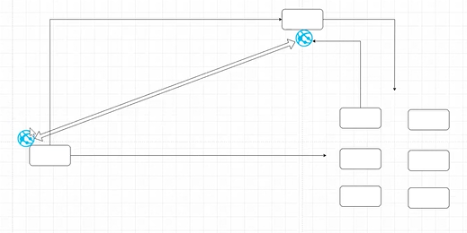

Get started with CloudFront

Enable accelerated, reliable and secure content delivery for Amazon S3 buckets, Application Load Balancers, Amazon API Gateway APIs, and more in 5 minutes or less.

**AWS Free Tier**

1 TB of data transfer out

10,000,000 HTTP or HTTPS requests

2,000,000 CloudFront Function invocations

Each month, always free

Pricing (US)

First 1 TB data transfer free each month

10 TB/month$0.085 per GB

HTTP requests$0.0075 per 10,000

HTTPS requests$0.0100 per 10,000

Customers willing to commit to 10 TB+/month are eligible for discounted pricing.

Cloudfront where it is used ?

**Deliver fast, secure websites**

Amazon CloudFront delivers your websites to viewers across the globe securely and with high performance. Granular cache configuration controls, built-in capabilities such as Gzip and Brotli compression, and edge compute capabilities speed up delivery while Transport Layer Security (TLS) 1.3 and field-level encryption helps you improve your application security posture.

**Accelerate dynamic content delivery and APIs**

CloudFront moves dynamic web content along the AWS global network infrastructure to accelerate delivery. CloudFront supports Websocket connections and proxy methods. CloudFront optimizes your network path with TLS edge termination and connection keep-alive. Secure your API calls with integrated AWS WAF and AWS Shield protection.

**Stream video live and on-demand**

CloudFront is designed to handle your live and on-demand video workloads. With full AWS and Elemental media services integration, CloudFront provides default mid-tier caching, Origin Shield architecture, and real time monitoring. CloudFront supports multiple streaming formats, including Microsoft Smooth, HLS, HDS, and MPEG-DASH, to any device.

**Distribute software, game patches, and IoT OTA updates**

CloudFront scales automatically as your globally distributed clients download software updates directly from edge locations. CloudFront’s high data transfer rates speed up the delivery of binaries, game patches, Internet of Things (IoT), and over-the-air (OTA) updates - improving your customers’ experience cost effectively at scale.

Now go to AWS Console and open Cloudfront

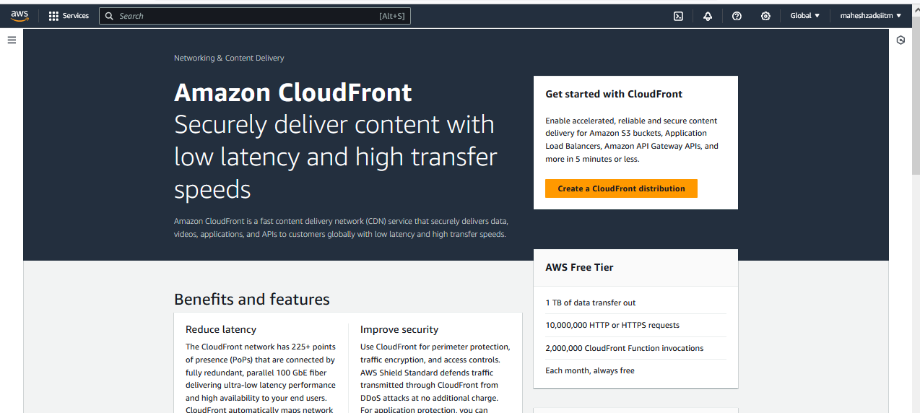

Cloudfront using S3

CloudFront Lab

Step 1 - Create a S3 Bucket with default options (if not already) and upload your html pages along with image if you have.

Give the Name of the bucket

Click on create bucket

Bucket created

Click on upload

Click on upload

click on add files

Click on upload

Step 2 - Create a CloudFront Distribution

Create distribution

Origin domain >>> Choose the bucket that you have created above

Origin path - optional >>> Leave it

Name >>> will be automatically picked up

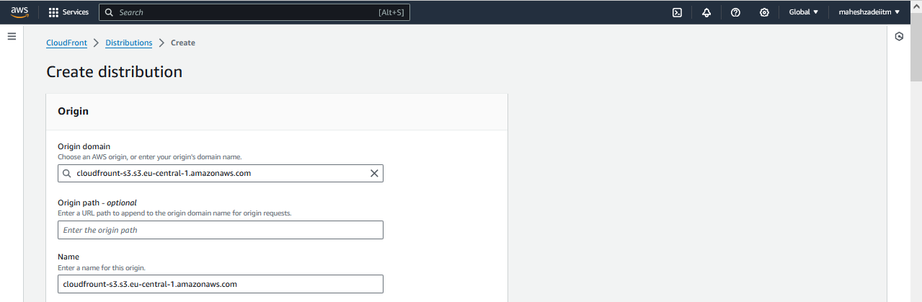

Origin access control settings (recommended)

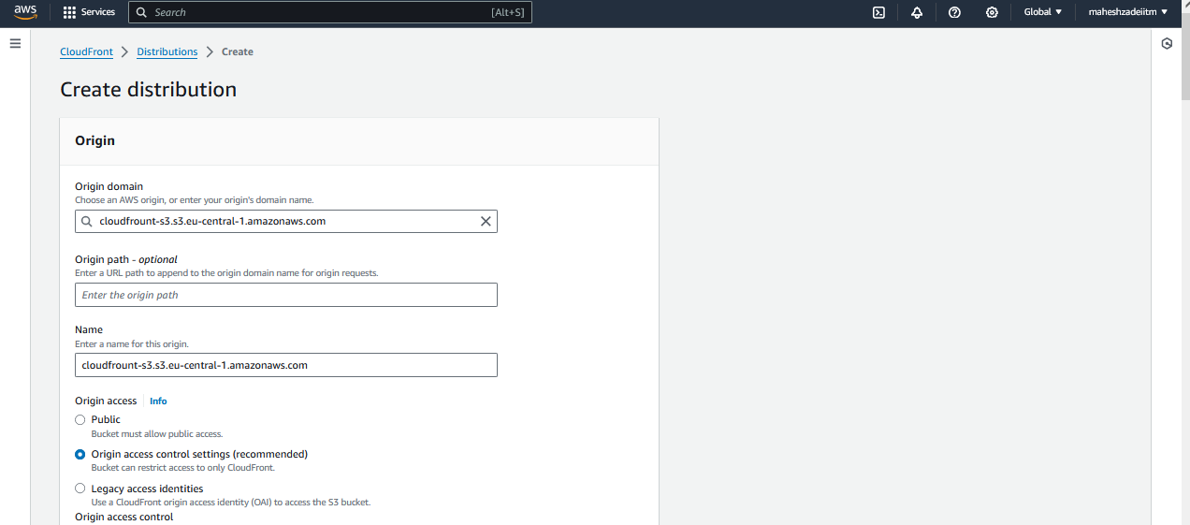

Origin access control >>>> create new OAC

New windows will be open, leave all the options as it is and then say Create >>>> why ??? it will create a custom S3 Bucket policy and enable a secure connection between S3 to CloudFront.

you should see this information after creation -

You must update the S3 bucket policy

CloudFront will provide you with the policy statement after creating the distribution.

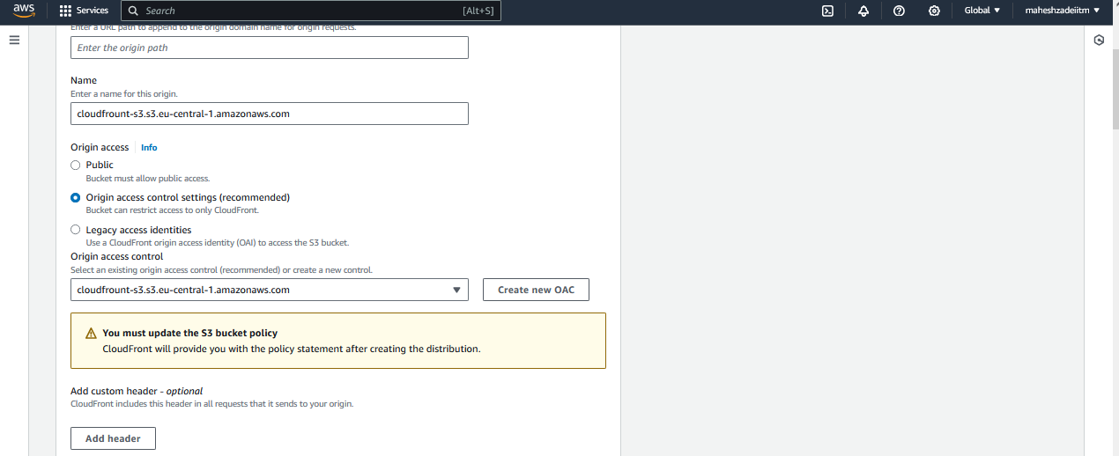

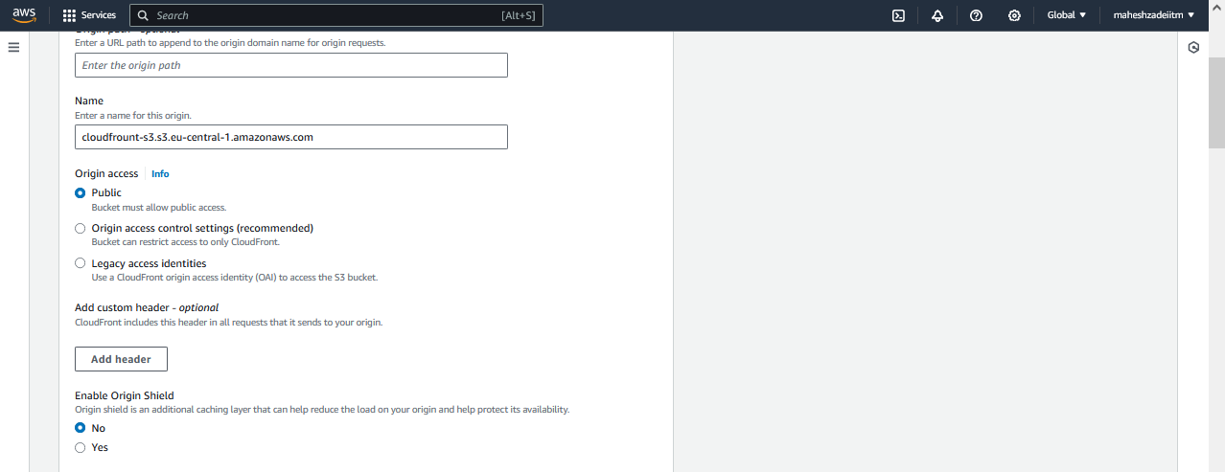

Cache key and origin requests >>>> Cache policy and origin request policy (recommended

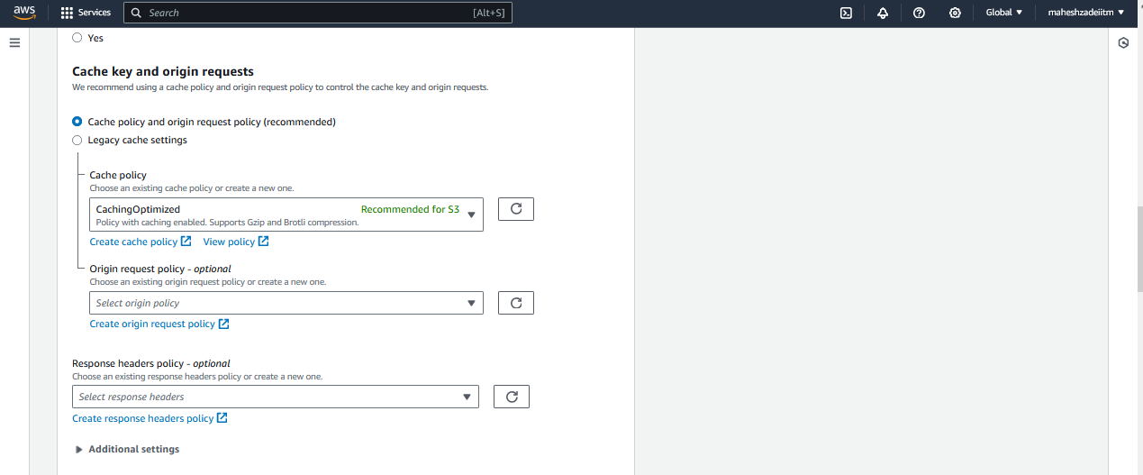

Leave optins as it is

Web Application Firewall (WAF) >>> Do not enable security protections

Price class >>>> Use all edge locations (best performance)

Supported HTTP versions >>>> HTTP/2

Default root object - optional >>>>> index.html

Upload the index.html from s3 bucket

Except above options, rest all are default

Click on create distribution

Now you can see at the top there is a new ribbon saying that >>>> The S3 bucket policy needs to be updated

Copy your S3 Bucket policy and Go to the S3 Bucket

Permissions >>> Edit bucket policy

Paste the bucket policy

Update the policy

Save changes and then policy updated

CloudFront Creation generally takes time - you have to wait till Last modified changing from Deploying to the timestamp

Distribution domain name is created

Copy distributed domain name and paste in the browser

<https://d7p6hy9cm5tsb.cloudfront.net>

Now my website is up and running

Pls check and confirm the Hands on for Cloudfront

Thanks

Mahesh Zade

Before deleting pls disable the Cloudfront distribution

Then delete after few minutes when the delete option is active.